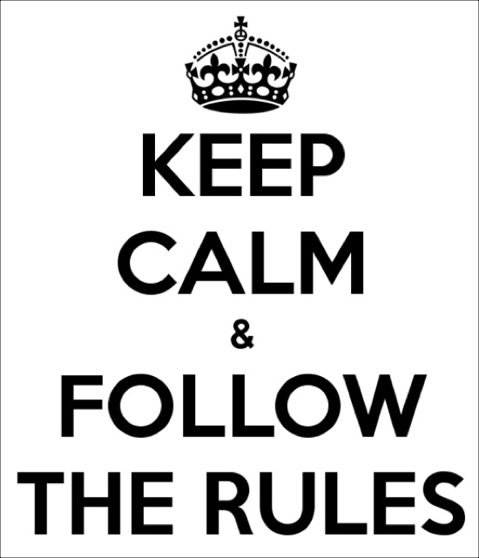
BREAK THE RULES DAY!
EYFS / KS1
K

K

DON’T
Thursday 28th March is “Break the Rules Day”!

For every rule you break you must pay 50p

Please tick the rules you are going to break and bring in this form along with payment to school with you on the day.

You can break as many or as few of these rules as you wish…………

GO ON… BE A RULE BREAKER – JUST FOR ONE DAY!

Name……………………………………………………………..

Class………………………………………………………………

Tick the rules that you are going to break:

Have a crazy hairstyle
Wear your hair down
Wear tattoos/glitter tattoos
Wear nail varnish
Wear crazy socks/tights
Wear a non-school uniform top/football shirt
Wear a non-school uniform short/skirt/dress
Wear non-school uniform shoes
Wear a hat
Bring an unhealthy snack for break (no nuts)
Bring squash in your water bottle
Eat your pudding before your main meal
Choose where you sit in the classroom
Bring your favourite cuddly toy to school to have with you in class
Have an outside lesson
Have extra playtime
Sit anywhere on the carpet
Time with our buddies (EYFS – please let your teachers know before Wednesday)

Total amount enclosed (50p per rule)……………………………………..

