June 2025

Dear Parents and Carers,

Please work with your child to complete the following pages.

Please bring to school on their first day to help us get to know them.

Many thanks,

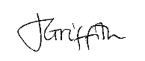

Jo Griffith
Headteacher

All About Me

My name is:

My birthday is:

Here is a photo of me: Please draw a picture of yourself:

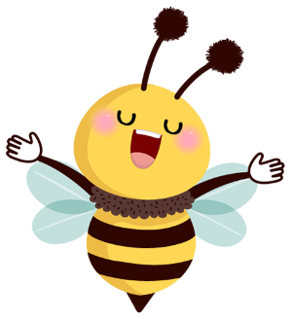
What makes me happy:


What upsets me:

My Family
Can you draw some pictures of your family?

I have ___________ brothers aged _____________ .

I have ___________ sisters aged ________________ .

Independence skills
What can you do?
  I can eat with a knife and fork. |  |  | 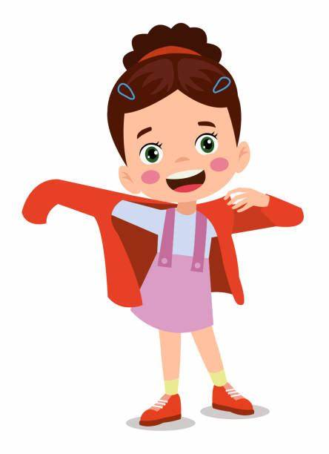  I can put my coat on. |  |  | 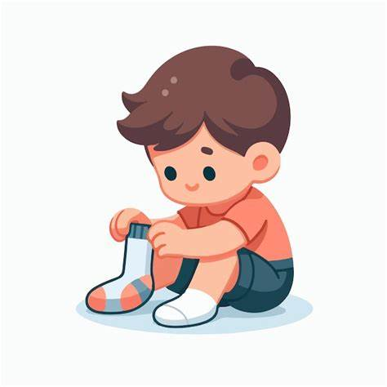  I can put my socks on .
Yes | No | Almost | Yes | No | Almost | Yes | No | Almost
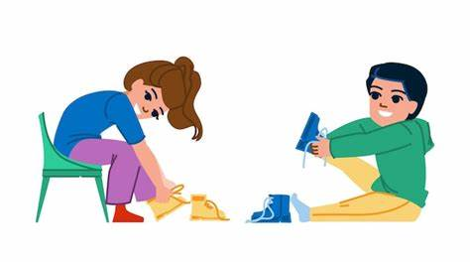  I can put my shoes on. |  |  | 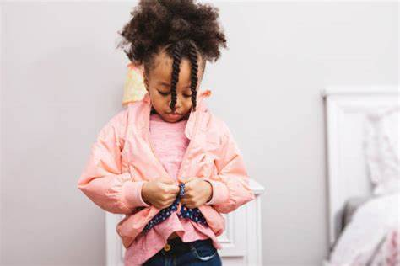  I can do up zips. |  |  | 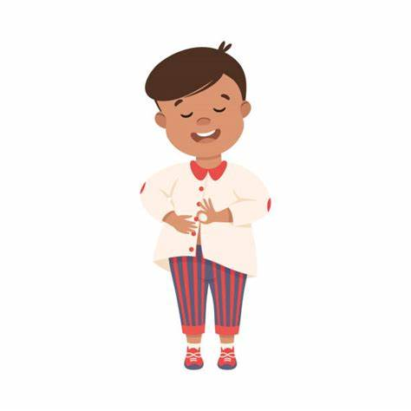  I can do up buttons.
Yes | No | Almost | Yes | No | Almost | Yes | No | Almost
  I can go to the toilet on my own. |  |  | 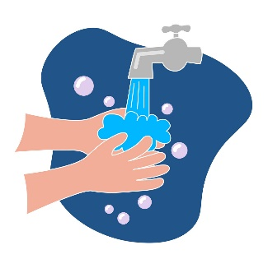  I can wash and dry my hands. |  |  | 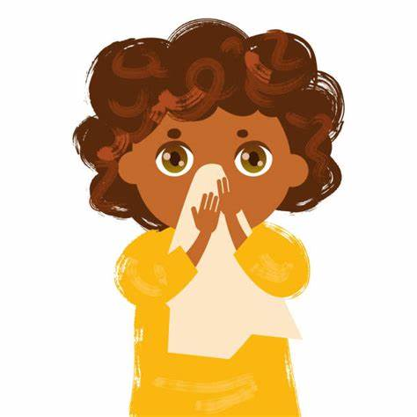  I can blow my nose.
Yes | No | Almost | Yes | No | Almost | Yes | No | Almost
Nursery/Preschool/Playgroup
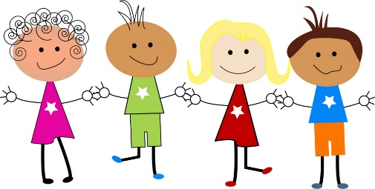

I went to _____________________________ nursery/preschool/playgroup.

When I was there I liked to ____________________________________________________________________________________________________________________________________________ .

When I start Holy Trinity School I am looking forward to
___________________________________________________________________________________________________________________________________________________________________________________________ .

Thank you for telling us all about you!


About My Child

Parents, if there is anything else you’d like us to know about your child please comment here. You may wish to tell us about your child’s readiness for school, any health issues (E.g allergies or special medications) or family circumstances (such as a new baby or other changes in the family). Thank you!

