Condition Data Collection 2

School Condition Report
Holy Trinity CofE Primary School, Sunningdale
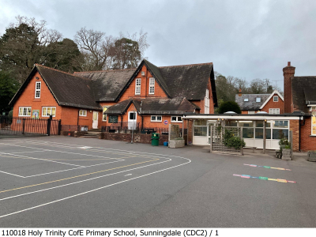
School Details
Establishment: Holy Trinity CofE Primary School, Sunningdale
Address: Church Road
Sunningdale
Ascot
Berkshire
SL5 0NJ
Local Authority Area: Windsor and Maidenhead
URN: 110018
LA/Establishment Number: 868/3322
Surveyor Visit Date: 16 December 2024
Engineer Visit Date: 16 December 2024
Surveying Organisation: Aecom
PLEASE DOWNLOAD THE CDC2 SCHOOL SITE PLAN TO READ IN CONJUNCTION WITH THIS REPORT
Contents
Section 1: Overview 2
Purpose of the Condition Data Collection 2 (CDC2) Programme 2
About the CDC2 School Condition Report 2
What can I use my CDC2 School Condition Report for? 2
CDC2 School Condition Report Content and Structure 4
CDC2 Methodology 4
Providing Feedback 5
Section 2: Site and Block Summary Information 6
Block Information Summary Table 6
Block Listing 7
Section 3: Condition Data – Poor & Bad Condition Elements 8
Annex A: How to Read Section 3 – Condition Data 14

Section 1: Overview

Purpose of the Condition Data Collection 2 (CDC2) Programme
The CDC2 programme is a data collection exercise being undertaken by the Department for Education (DfE). Data is being collected on the condition of buildings of all government funded educational establishments in England.
The programme is designed to enable a fair distribution of capital maintenance funding to responsible bodies such as academy trusts, local authorities and dioceses. Its use to DfE can be summarised as:
- Enabling capital allocations which are informed by school condition
- Identifying school blocks in need of replacement
- Supporting the development of capital allocations policy

About the CDC2 School Condition Report
The CDC2 school condition reports are set out in the table below.
Document | Information Provided
School Condition Word Report (this report) | Summary and condition information about each block
School Photo Pack | All photographs, including condition and roof photos
School Site Plan | A site plan marked up with site boundary lines and block references used by DfE for the CDC2
School Condition Spreadsheet Report | All CDC2 condition data recorded against your school and buildings, in spreadsheet form for easier analysis
Table 1: Descriptions of CDC2 documents available to schools

What can I use my CDC2 School Condition Report for?
CDC2 condition data for your school is presented in this report for your information and use. Please note: the words ‘school’ or ‘schools’ as used in this report refer to schools and all other educational establishments within scope of CDC2.
CDC2 data is designed to provide a consistent and comparable view of condition across the education estate. The data collection process is not invasive nor a structural survey, and the report generated from the data is not suitable for asset management purposes on its own.
This is because the report:
- Does not report on hazardous materials (e.g. asbestos)
- Does not address critical health and safety (H&S) requirements
- Does not assess a school’s compliance with all statutory and legislative responsibilities
- Does not assess building capacity or suitability issues
- Does not propose remedial actions to address condition issues
- Does not include any cost information
The CDC2 school condition report, can, however:
- Help you build an understanding of condition need at your school
- Highlight condition issues which need attention or further investigation (e.g. through a full condition survey or project feasibility study)
- Provide a view of roof condition
- Provide photographic evidence of condition issues (C, D, Bx and Cx only)
- Be used by academies and trusts in support of Condition Improvement Fund (CIF) bids alongside your own detailed condition surveys

CDC2 School Condition Report Content and Structure
This report is split into three sections plus an annex containing guidance:
Section 1 – Overview | An overview of the CDC2 programme, methodology and school condition report content
Section 2 – Site and Block Summary Information | Summary information and photographs for each block on your site(s)
Section 3 – Condition Data Summary Tables | The ‘poor’ and ‘bad’ condition and priority grades recorded for your buildings and school external site areas (including playing fields)
Annex A – How to Read this Report | Guidance on how to read Section 3
Table 2: Report content summary

CDC2 Methodology
Buildings at each school are divided into ‘blocks’ which are identified by their age and construction type. Where schools have more than one site the report provides details for the blocks in each site. Some buildings on your site may be split into more than one block.
A total of twelve common building elements (e.g. roofs, floors/stairs, ceilings) have been visually assessed by CDC2 surveyors during the site visit, and have a condition grading and a priority rating attributed to them.
Further information about the condition assessment methodology used by CDC2 surveyors can be found in the CDC2 programme guide.

Providing Feedback
You will have the opportunity to provide feedback via the web-based CDC2 school feedback survey. You will have received a hyperlink to the CDC2 feedback survey contained in the condition report notification email.
You have limited time in which to complete your feedback survey
Your feedback survey response must be completed within three weeks of receiving the condition report notification email.
If a school condition report is released outside of term time, the feedback survey deadline will be extended.

Section 2: Site and Block Summary Information
This section contains summary information about each block on each site. A photograph of each block is provided, together with the DfE block reference (“EFAA”, “EFAB”, etc.) and surveyor assessed age range for the block, floor area and other descriptive information.
A ‘site’ refers to the parcel of land used by a school with a reference (e.g. “EFA1”). A separate parcel of land (e.g. separate playing fields) will have a separate site reference.
The site and block references used correspond to those used on the CDC2 site plan.
Further guidance on how to access the CDC2 site plan, spreadsheet report and photo pack documents is set out in the school condition report notification email or can be accessed on the CDC2 page on gov.uk.
You will need to have your CDC2 site plan and photo pack to hand when reading this report. The site plan provides a visual key to the block references used in Section 3 of this report.

Block Information Summary Table
Site | Block | Block Age Range | GIFA (m2)
EFA1 | EFAA | Pre 1900 | 1484
EFA1 | EFAB | 2011-2020 | 76

Total GIFA: 1560 m2
(Total GIFA does not include ANC blocks)

Block Listing
Summary details for each block are shown below.
Blocks named “ANC1”, “ANC2” etc. are ancillary blocks which are not used specifically for education purposes, such as sheds, ex-caretaker bungalows in residential use and garages. CDC2 surveyors do not collect full condition information for ancillary blocks and they are not listed in the table below.

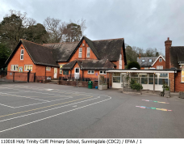 | Site | EFA1
 | Block | EFAA
 | Building Age | Pre 1900
 | No. of Storeys | 2
 | Basement Area (m2) | 0
 | Gross Internal Floor Area (m2) | 1484
 | Ground Floor GIFA (m2) | 1345
 | Perimeter (m) | 277
 | Average Height (mm) | 4600
 | Catering Kitchen | Yes

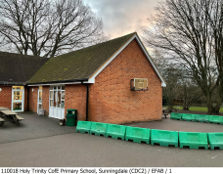 | Site | EFA1
 | Block | EFAB
 | Building Age | 2011-2020
 | No. of Storeys | 1
 | Basement Area (m2) | 0
 | Gross Internal Floor Area (m2) | 76
 | Ground Floor GIFA (m2) | 76
 | Perimeter (m) | 27
 | Average Height (mm) | 2625
 | Catering Kitchen | No

Section 3: Condition Data – Poor & Bad Condition Elements
Section 3 presents a summary of the condition information and photographs collected by the surveyors and engineers at the school visit for construction types assessed as C, D, Bx and Cx (C=poor, D=bad, Bx and Cx = requiring full replacement). Where there are different grades of condition apparent across a construction type, a percentage grade is applied. As each of the tables below only presents a subset of the all the condition grades applied, the aggregated condition grades will not always add up to 100%. Please note that if your school doesn’t have any Bx, Cx, C or D condition grade elements, the section below will be blank.

A full table of all condition gradings is available in the school CDC2 spreadsheet report, available separately for download via the CDC2 portal.

The table row headings and condition grades used here and in the CDC2 spreadsheet report are explained in Annex A of this report.

Summary Tables - Construction types assessed as Bx, Cx, C, D

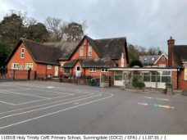 | Photo Reference | EFA1/11.07.01
 | Location | EFA1
 | Element Code | 11.07.01
 | Element/Sub Element | 11. Site Areas & External Areas / 11.07. Fences, Walls, Barriers etc (Exc. Site Boundary) /
 | Construction Type | Brick / Block / Concrete / Stone
 | Condition Grade Bx% | 0
 | Condition Grade C% | 15
 | Condition Grade Cx% | 0
 | Condition Grade D% | 0
110018 Holy Trinity CofE Primary School, Sunningdale (CDC2) Survey

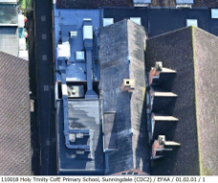 | Photo Reference | EFAA/01.02.01
 | Location | EFAA
 | Element Code | 01.02.01
 | Element/Sub Element | 01. Roofs / 01.02. Flat Roof Covering and Insulation /
 | Construction Type | Flexible Sheet; Single Ply or Built Up
 | Condition Grade Bx% | 0
 | Condition Grade C% | 50
 | Condition Grade Cx% | 0
 | Condition Grade D%
110018 Holy Trinity CofE Primary School, Sunningdale (CDC2) Survey

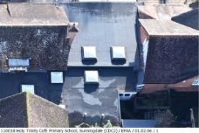 | Photo Reference | EFAA/01.02.06
 | Location | EFAA
 | Element Code | 01.02.06
 | Element/Sub Element | 01. Roofs / 01.02. Flat Roof Covering and Insulation /
 | Construction Type | Glazed Areas / Rooflights
 | Condition Grade Bx% | 0
 | Condition Grade C% | 50
 | Condition Grade Cx% | 0
 | Condition Grade D%
110018 Holy Trinity CofE Primary School, Sunningdale (CDC2) Survey

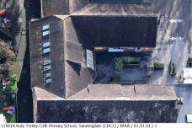 | Photo Reference | EFAA/01.03.02
 | Location | EFAA
 | Element Code | 01.03.02
 | Element/Sub Element | 01. Roofs / 01.03. Pitched Roof Covering and Insulation /
 | Construction Type | Tiles
 | Condition Grade Bx% | 0
 | Condition Grade C% | 35
 | Condition Grade Cx% | 0
 | Condition Grade D%
110018 Holy Trinity CofE Primary School, Sunningdale (CDC2) Survey

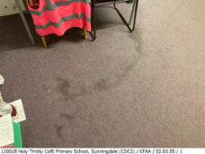 | Photo Reference | EFAA/02.03.05
 | Location | EFAA
 | Element Code | 02.03.05
 | Element/Sub Element | 02. Floors and Stairs / 02.03. Floor Applied Finish /
 | Construction Type | Carpet
 | Condition Grade Bx% | 0
 | Condition Grade C% | 15
 | Condition Grade Cx% | 0
 | Condition Grade D%
110018 Holy Trinity CofE Primary School, Sunningdale (CDC2) Survey

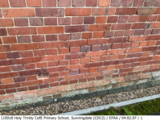 | Photo Reference | EFAA/04.02.07
 | Location | EFAA
 | Element Code | 04.02.07
 | Element/Sub Element | 04. External Walls, Windows and Doors / 04.02. External Envelope /
 | Construction Type | Exposed Loadbearing Masonry
 | Condition Grade Bx% | 0
 | Condition Grade C% | 5
 | Condition Grade Cx% | 0
 | Condition Grade D%
110018 Holy Trinity CofE Primary School, Sunningdale (CDC2) Survey

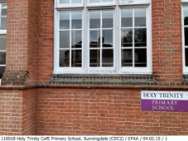 | Photo Reference | EFAA/04.02.15
 | Location | EFAA
 | Element Code | 04.02.15
 | Element/Sub Element | 04. External Walls, Windows and Doors / 04.02. External Envelope /
 | Construction Type | Component Timber Windows & Doors
 | Condition Grade Bx% | 0
 | Condition Grade C% | 100
 | Condition Grade Cx% | 0
 | Condition Grade D% | 0
110018 Holy Trinity CofE Primary School, Sunningdale (CDC2) Survey

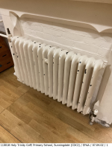 | Photo Reference | EFAA/07.04.02
 | Location | EFAA
 | Element Code | 07.04.02
 | Element/Sub Element | 07. Mechanical Services / 07.04. Heat Emitters and Pipework /
 | Construction Type | Wet System Emitters
 | Condition Grade Bx% | 10
 | Condition Grade C%
 | Condition Grade Cx%
 | Condition Grade D%
110018 Holy Trinity CofE Primary School, Sunningdale (CDC2) Survey

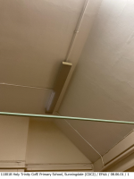 | Photo Reference | EFAA/08.06.01
 | Location | EFAA
 | Element Code | 08.06.01
 | Element/Sub Element | 08. Electrical Services / 08.06. Lighting /
 | Construction Type | Luminaires
 | Condition Grade Bx% | 5
 | Condition Grade C% | 0
 | Condition Grade Cx% | 0
 | Condition Grade D% | 0
110018 Holy Trinity CofE Primary School, Sunningdale (CDC2) Survey

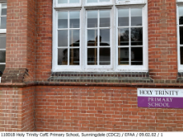 | Photo Reference | EFAA/09.02.02
 | Location | EFAA
 | Element Code | 09.02.02
 | Element/Sub Element | 09. Redecorations / 09.02. External - Windows Doors and External Joinery /
 | Construction Type | Painted
 | Condition Grade Bx% | 0
 | Condition Grade C% | 50
 | Condition Grade Cx% | 0
 | Condition Grade D%
110018 Holy Trinity CofE Primary School, Sunningdale (CDC2) Survey

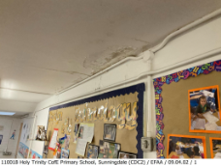 | Photo Reference | EFAA/09.04.02
 | Location | EFAA
 | Element Code | 09.04.02
 | Element/Sub Element | 09. Redecorations / 09.04. Internal - Ceilings /
 | Construction Type | Painted
 | Condition Grade Bx% | 0
 | Condition Grade C% | 25
 | Condition Grade Cx% | 0
 | Condition Grade D%
110018 Holy Trinity CofE Primary School, Sunningdale (CDC2) Survey

Annex A: How to Read Section 3 – Condition Data
This annex provides a description for each of the row headings in the condition data summary tables found in Section 3 of this report, and explains how to cross-reference with the photos in your photo pack (which will be made available for you to download separately from the CDC2 portal).
You will need to have your CDC2 site plan to hand when reading this report. It provides a visual key to the block references used in Section 3 of this report, which are explained below.
‘Photo Reference’
This row provides a reference that you can use to look up the relevant photo in the school photo pack, if you want to look at a more detailed photo of the construction type. A photo reference contains the ‘Location’ (site or block) and ‘Construction Type Code’ information from the same row in the table.

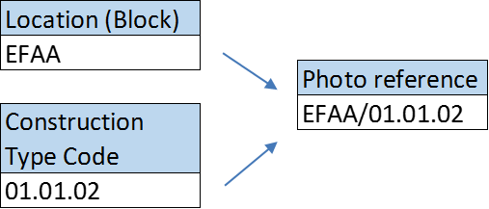

Figure 1: Photo reference example

‘Location’

Standard blocks
Site references contain a unique number. Block references (with the exception of ‘ancillary blocks’) are labelled AA-BZ.
External areas
Some rows in the condition data summary tables in Section 3 will show a site reference only in the location row (i.e. the block reference is absent). This means that the information contained in that row relates to external areas, and is not ‘attached’ to a block.
The condition data in Section 3 does not provide condition information for ‘ancillary blocks’
The CDC2 surveying team do not record condition data for ancillary blocks such as garages, sheds and external stores, which is why ancillary blocks do not appear in the condition data in Section 3.

‘Element / Sub Element’ and ‘Construction Type’
Condition is assessed for twelve main building ‘elements’. Each of these is split into sub-elements that in turn are split into construction types.
Example:
Element: | 01. Roofs
Sub element: | 01.03. Pitched Roof Covering and Insulation
Construction type: | Natural Slates

Table 3: Element, sub element and construction type hierarchy

‘Condition Grade %’
These rows set out the condition assessment grade information for each construction type assessed within each block.
Where there are different grades of condition apparent across a construction type when assessed by the surveyors, a percentage grading is applied. For example, ‘internal flooring’ could have 40% at condition grade D and 60% condition grade C.
The condition grades are defined as follows:
Grade | Condition | Description
A | Good | Performing as intended
B | Satisfactory | Performing as intended, but exhibiting minor deterioration
C | Poor | Exhibiting major defects and/or not operating as intended
D | Bad | Life expired and/or serious risk of imminent failure
X | Full Replacement | Supplementary designation assigned in addition to ‘B’ and ‘C’ where full replacement is required  For example, a boiler may be assessed as “Cx” if the surveyor judges it to be in poor condition but is aware that it is obsolete and that it will no longer be possible to get the necessary spare parts due to its age
Table 4: Condition Grade descriptors

END OF REPORT

