Supporting governors’ self-review through the lens of the Quality of Education section of the Inspection Framework
These questions have been created after reviewing ‘The Key for School Governors’, The Competency Framework for Governors and by drawing upon resources produced by Governors for Schools.
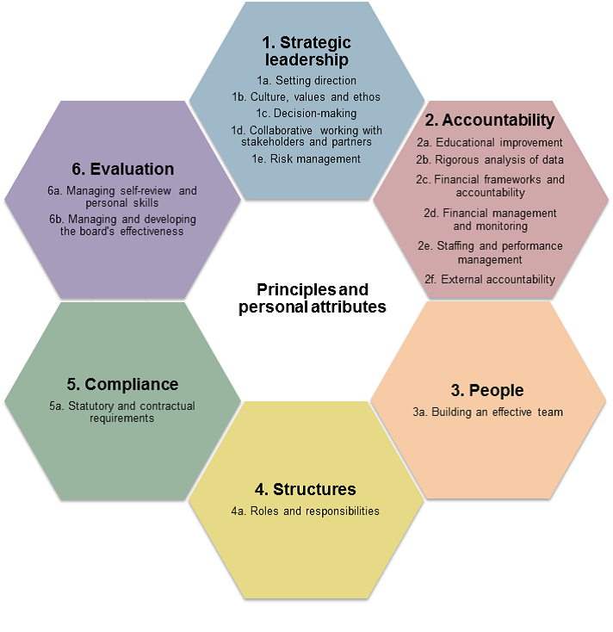
From the Competency Framework for Governors (2016)
Quality of education: curriculum intent, implementation, impact. (Evidence column contains examples – Governing Board to supply its own)
Question | Evidence | notes – CURRENT strengths and AREAs FOR DEVELOPMENT
INTENT
What are the key drivers shaping our school’s curriculum?  How do our school’s values underpin the curriculum?  What is the ‘wider offer’ beyond the National Curriculum? | - School improvement plan  - Self-evaluation form (SEF)  - School vision statement and aims  - Curriculum and assessment policies, and evidence that these link to the school’s vision and values  - Feedback from parents, staff and pupils  - Governors’ minutes  - Dialogue with school leaders  - School’s curriculum statement  - School’s website – curriculum area overviews
What involvement has our governing board had in shaping the vision for the school’s curriculum?  What is the vision for two years’ time?  What is meant by cultural capital and knowledge rich? | - Minutes from governors’ meetings  - Curriculum ‘Sway’  - Programme of experiential education  - Dialogue with leaders  - School’s strategic priorities  - School’s Improvement Plan and SEF
How does our school’s curriculum take account of the diversity of the school and ensure equal access?  OR  How have we designed the curriculum to meet the needs of all children? | - Accessibility information on school’s website  - Equality Information  - Reports from link governors  - Minutes and reports from Governing Board  - Curriculum planning records  - Inclusion statement
Are we prepared for the introduction of Sex and Relationships Education in 2020? | - Discussion with senior leaders  - Discussion with parents e.g. parents’ evenings  - Draft policy and information for parents
Do our terms of reference and code of conduct reflect the Governors’ strategic priorities with regards to the curriculum?  Does our governance structure allow us to have a strategic overview of the curriculum and its intent? | - Terms of reference  - Governors’ roles (no requirement for Governors to be attached to each subject area)  - Code of conduct  - Responsibilities aligned with school’s strategic priorities  - Governing Board agendas and minutes  - Skills audit
IMPLEMENTATION (Operational more than Strategic)
How do we know that teachers have the subject knowledge required to deliver the curriculum well? | - Reports on appraisal priorities  - Professional learning overviews  - Minutes from governors’ meetings  - Reports from governors
How are we planning for, teaching and assessing Science?  Who is accountable in school?  NB National data from sampling indicates that standards in science in primary schools have fallen | - Curriculum intent statement  - External consultant’s reports
How do we evaluate whether the curriculum in our school is broad and balanced? | - Curriculum policies and intent statements  - Minutes from governors’ meetings  - Evidence from monitoring visits or learning walks  - Reports from link governors
Are milestones built into curriculum plans? | - Examples from small step documents/curriculum overviews  - Other progression documents e.g. Grammar
What are the arrangements for curriculum and subject leadership in the school? | - TLR accountabilities and appraisal reviews  - Staffing responsibility overviews
How do we quality assure collectively that reading and writing are prioritised across the curriculum? | - Book looks/discussions with children and parents  - Evidence from reports from school leaders
IMPACT
How do we hold school leaders to account and evaluate the effectiveness of the curriculum? | - Pupil outcomes  - School development/improvement plan  - Feedback from parents, pupils and staff  - Minutes and reports from governors’ meetings  - Reports from external advisors  - School’s participation is wider networks  - Leadership at PW (document containing all the standards and career expectations & used to inform appraisal
How do we monitor achievement for pupils in receipt of the pupil premium?  What do we mean by disadvantaged and are other children in the school who are disadvantaged? | - Pupil premium strategy and impact report  - National attainment data
Outcomes for children with SEND (not measured against children with no SEND or children with SEND nationally) | - Governors’ SEND information report
Do children make a good transition into the next stage of their education? | - Good Level of Development, Phonics, KS1 and KS2 outcomes  - Observations of children’s behavior and personal development
How do we know that children are learning the curriculum and therefore making progress?  Are there any variations within or between year groups?  NB Quality of teaching is the about the implementation of the curriculum | - Standardized reading scores and progress from phonic outcomes to end of year outcomes (new reports in response to a new accountability measure)  - Lesson visit reports (collective outcome, no individual information)  - Assessment policy and examples of assessment in practice  - High Performance Learning reports (high achievers)

