Monday 11th January 2021
Our new topic this term is Space.

Have a look at the pictures of Space below.

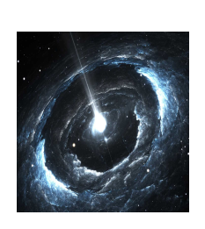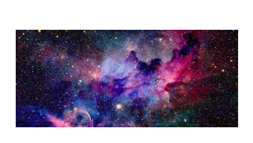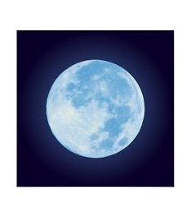

Print off a picture and stick it in the middle of the next page in your workbook.
Write as many facts or just words, that you can think of about Space.
Please put the date at the top of your page.
When you have finished this task, watch The Moon Landing clip below

https://www.youtube.com/watch?v=CbTaDOuSePk

