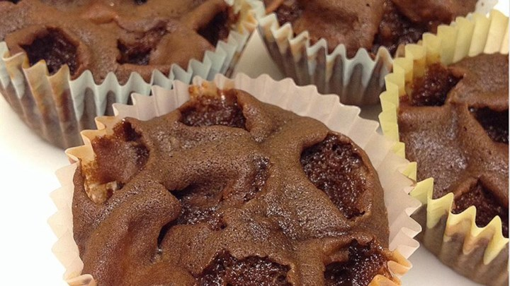
Moon Rock cookies

- 1 cup semisweet chocolate chips
- 2 cups all-purpose flour
- 1 1/2 teaspoons baking soda
- 1/2 teaspoon salt
- 1/2 cup butter, softened
- 1 1/2 cups packed light brown sugar
- 3 eggs
- 1 teaspoon vanilla extract
- 1 cup water
- 2 cups miniature marshmallows

- Preheat oven to 350 degrees F (175 degrees C).
- Melt chocolate in the top of a double boiler. Let cool.
- In a mixing bowl, combine flour, baking soda and salt. In a separate bowl, cream butter and sugar together. Blend eggs into the butter mixture one at a time. Stir the vanilla, flour mixture, water and chocolate into the butter and eggs; beat well. Stir in marshmallows. Fill paper-lined cupcake pans half full.
- Bake in a preheated 350 degrees F (175 degrees C) oven for 20 minutes. Cool on a wire rack before serving

