Maths
Monday -– Thursday

Money

Monday
Please follow the links below to find out your Maths challenge for today.
https://youtu.be/4nxOBQuctRM lesson

https://youtu.be/0Qn--ctfsgY challenge

Tuesday
Please follow the link below to Oak National Academy https://classroom.thenational.academy/lessons/to-exchange-money-for-items-crv3j

Wednesday

Today you are going to create your own toy shop.
Please choose 6 -8 toys.
Choose how much money each toy will be between 1p and 15p. Put a price tag on each toy.

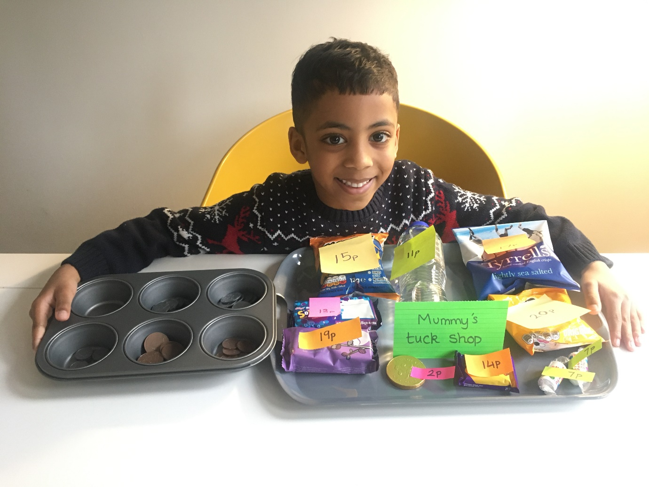
Can you create a shop like Zen but with toys?
Thank you so much for your tuck shop Zen.

Now can you choose 2 items to buy?
Eg a bottle of water for 11p and a coin for 2p

The number sentence will be:
11p + 2p =

Use your number line or your counting objects to help you.
The answer will be:

11p + 2p = 13p
Which coins did you use to buy these two items?

So your task today is to:
1.– Create your toy shop.
2. Buy two items, write the number sentence, find the total.
3. Which coins did you use?

Bronze –- 2 number sentences with total and show which coins were used.
Silver –- 3
Gold _ - 4
Thursday

Please follow the link below to Oak National Academy
Today you are learning how to find change.
https://classroom.thenational.academy/lessons/to-calculate-the-amount-of-change-needed-part-1-69j3ee

