Wednesday – Religion

Please listen to the story Waterbugs and Dragonflies:
https://www.youtube.com/watch?v=VyRPJo8YBbY

Then also watch the animated story:
https://www.youtube.com/watch?v=paBhPPtJC_4&t=7s

Discuss with your adult helper:

What was the story about?
Where do you think waterbug went?
Do you know what happened to Jesus at Easter time?
Why do you think Easter is important to Christians?

Task
Go for a walk around your local area, to the park, in the woods or forest or around a lake. Can you see any signs of Easter or New life? T
Think about - How does Spring differ from the other seasons?
In your book, draw a picture of what you have seen. Write a list of words or write short sentences to describe what you have discovered.
eg
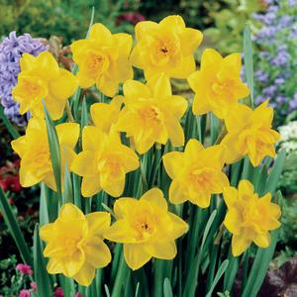
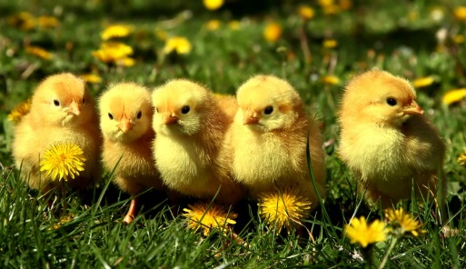
daffodils
chicks

