English
Week 2
Monday 11th - Thursday 14th
Man on the Moon
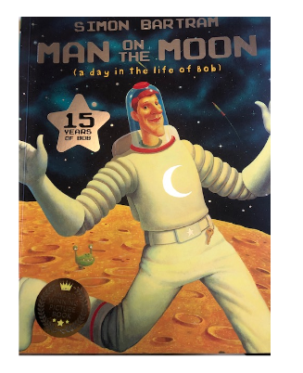

Monday 11th January 2021
Please have a look at the picture of Bob in his front room on the next page.
Then go to the following page and think about the questions that I have asked.
You could discuss these questions with your grown up who is helping you today.
Once you have thought or talked about the questions, focus on question 5.
What would you like to know about Bob?
Please get out your book and on a new page, put the date and title.

Monday 11th January 2021
Questions for Bob

Bronze - 2 questions
Silver - 3-4 questions
Gold - 5 questions

Don't forget a CL to start and a question mark at the end of each question.
Each question on a new line.
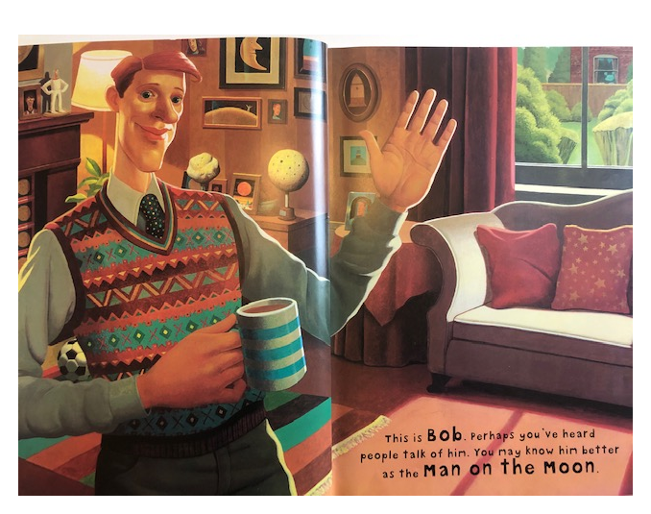
Eg Have you ever visited the Moon or any other planets?

1. What does the picture remind you of?
2. What do we know about Bob?
3. Would you like to meet Bob? Why?
4. What do you think Bob's hobbies might be?
5. What would you like to know about Bob?

Tuesday 12th January 2021
Listen to the story by clicking on the link below:

Story Introduction
https://youtu.be/zR7q1uIb9Pg
Man on the Moon story
https://youtu.be/M2tzOk3--d4

Listen carefully for information that will answer your questions that you wrote yesterday.
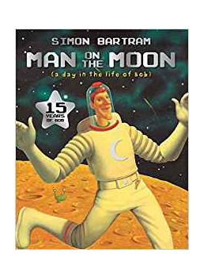
Describe your favourite part of the story.
Why is it your favourite?
Talk to your adult helper.

Please continue the sentences below:

My favourite part of the story was….

Now tell we why?

Eg
My favourite part of the story was when Bob looked inside the craters before he left the Moon for the day.

It made me laugh because there were four funny aliens hiding and Bob couldn’t see them.

Please put a date and title in your book

Tuesday 12th January 2021
I can describe my favourite part of the story

Once you have finished your writing, please draw a picture of your favourite part of the story in your book underneath.

Wednesday 13th January 2021
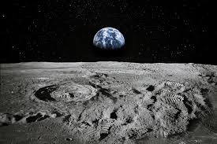

Look at the picture above.
What do you think it would be like to walk on the Moon?
How would you feel?
What would you see?
What would you hear?
What would you smell?
Talk to your adult helper.
Think of some good describing words (adjectives)
Eg
Feel - excited, curious, worried, happy
See - deep craters, red dust, bumpy rocks
Hear - spooky gurgling, swirling wind, whizzing rockets
Smell - stinky dust, smelly aliens

Please put a date and title in your book
Wednesday 13th January 2021
I can describe the Moon

How many can you think of?

Feel
See
Hear
Smell

Thursday 14th January 2021

Pretend that you are a tourist who has just been to visit the Moon.
Today you are going to write a postcard to a member of your family or friend, describing your exciting adventure!

Remember how you all sent a postcard to the year one teachers after your summer holidays.

What might you include in your postcard?

You will need to use some of your descriptive words from yesterday to include in your writing.

Eg
Dear…Year One,_____
How are you?
I have just had a very exciting trip to the Moon.
I was a bit nervous but it was amazing.
I saw deep craters and red dust.
I heard swirling winds and whizzing rockets.
The air was a bit stinky. I could smell yucky cheese.
Love Mrs Rhodes

Use the template attached under Thursday English and draw a picture of your adventure.

We will share these the following week so please stick the sheet in your book

