Tuesday

The Way Back Home
I can write and answer questions.

What might Oliver and the Martian be saying to each other in the pictures below?
Can you create a question and an answer for each character?
Don’t forget to include a ? question mark at the end of your question.
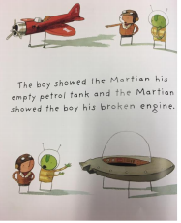
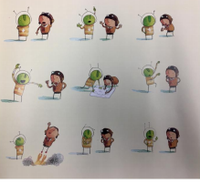

Oliver ( question ) _____________________________________________________________

________________________________________________________________________________________________

_______________________________________________________________________________________________

Martian ( answer ) ___________________________________________________________

______________________________________________________________________________________________

_______________________________________________________________________________________________

Martian ( question)____________________________________________________________

________________________________________________________________________________________________

________________________________________________________________________________________________

Oliver ( answer ) _________________________________________________________________

________________________________________________________________________________________________

________________________________________________________________________________________________

Please write your questions and answers straight into your book if you prefer.

