

Holy Trinity CE Primary School
School Council Minutes

29/01/19
Present: Mrs Griffith, Molly, Harry, Alex, Sophie, Hannah, William, Kate, Woody, Benoit, Amba, Neive and Aidan
- Molly welcomed the councillors & opened the meeting with the School Council Prayer.
- Playground Equipment we have been given £1000 by PTA to fund the garden and playground equipment. Molly shared the play equipment bundle we have chosen
- Wishing Tree all wishes that we asked for have been granted. Wished hung back on the tree with a tick to show they have been bought by PTA.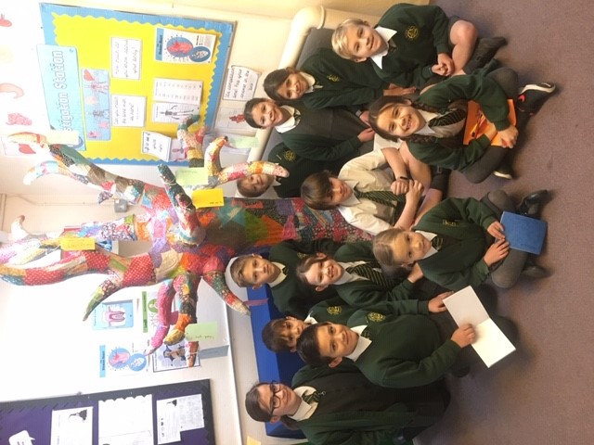
Actions:

- Hang wishes on the wish tree
- Hannah to write a thank you letter to PTA
- School Council to lead Collective Worship on 4/2/19
Next meeting is at 9am on Tuesday 12th February in Research Hub

